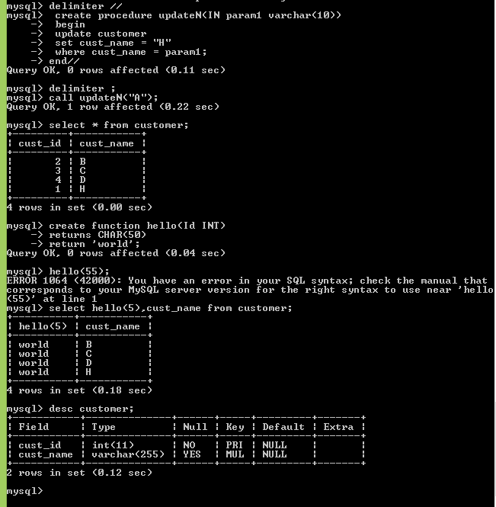

// Delete procedure

Drop procedure if exists procedure_name;

You have rows that contain nulls and would like to return non-null values in place of those nulls.

Solution

Use the function COALESCE to substitute real values for nulls:

1 select coalesce(comm,0)

2 from emp

Discussion

The COALESCE function takes one or more values as arguments. The function returns the first non-null value in the list. In the solution, the value of COMM is returned whenever COMM is not null. Otherwise, a zero is returned.